**JENKINS ASSIGNMENT**

**GitHub hook trigger for GIT SCM polling**

**1.**Enter description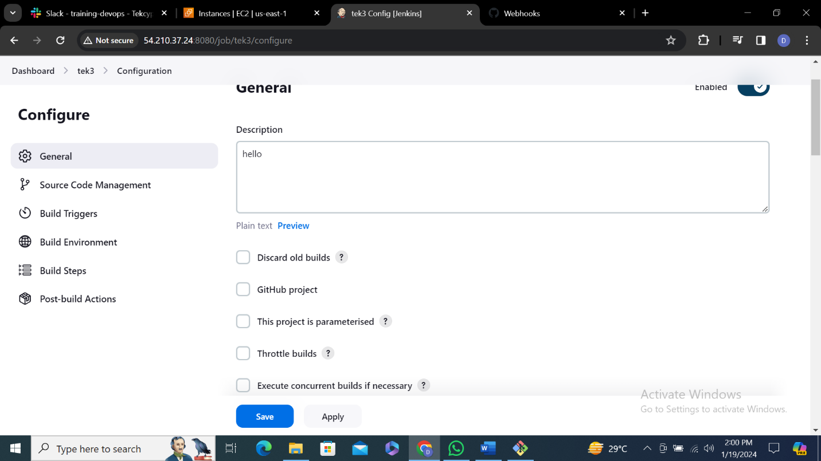

**2.**Paste git repository url from git hub

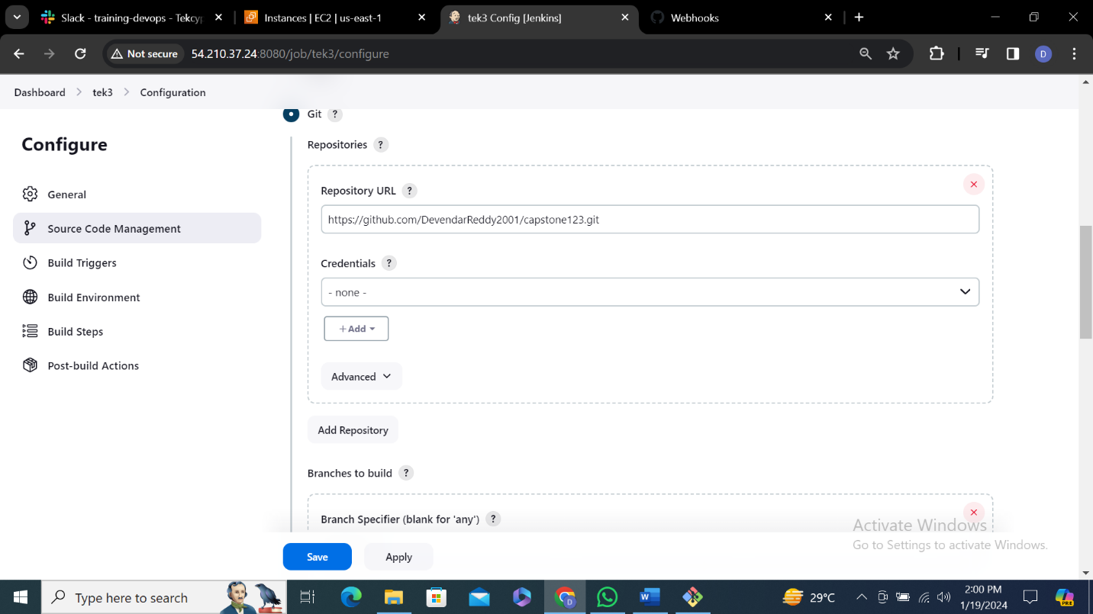

3.Select hook trigger for git scm polling

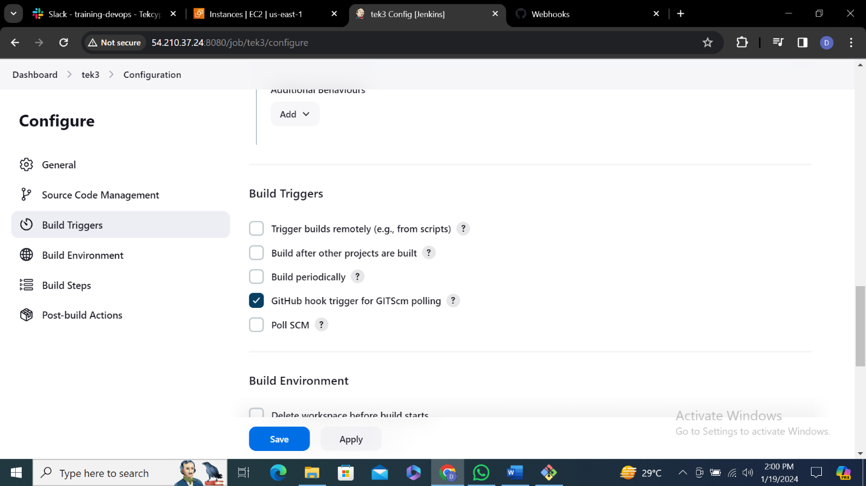

4.Click on save

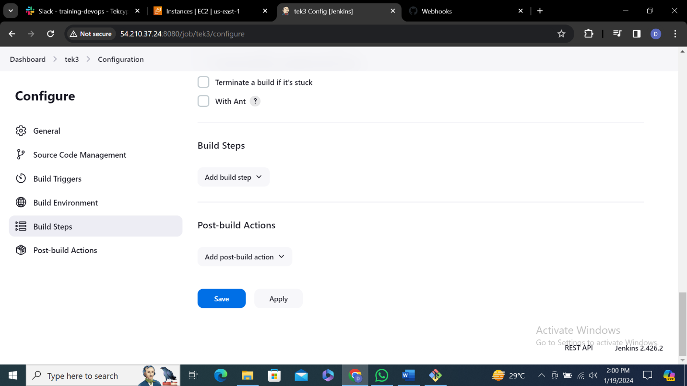

5.Go to git hub click on setting left side you will see a webhook click on it and click add webhook

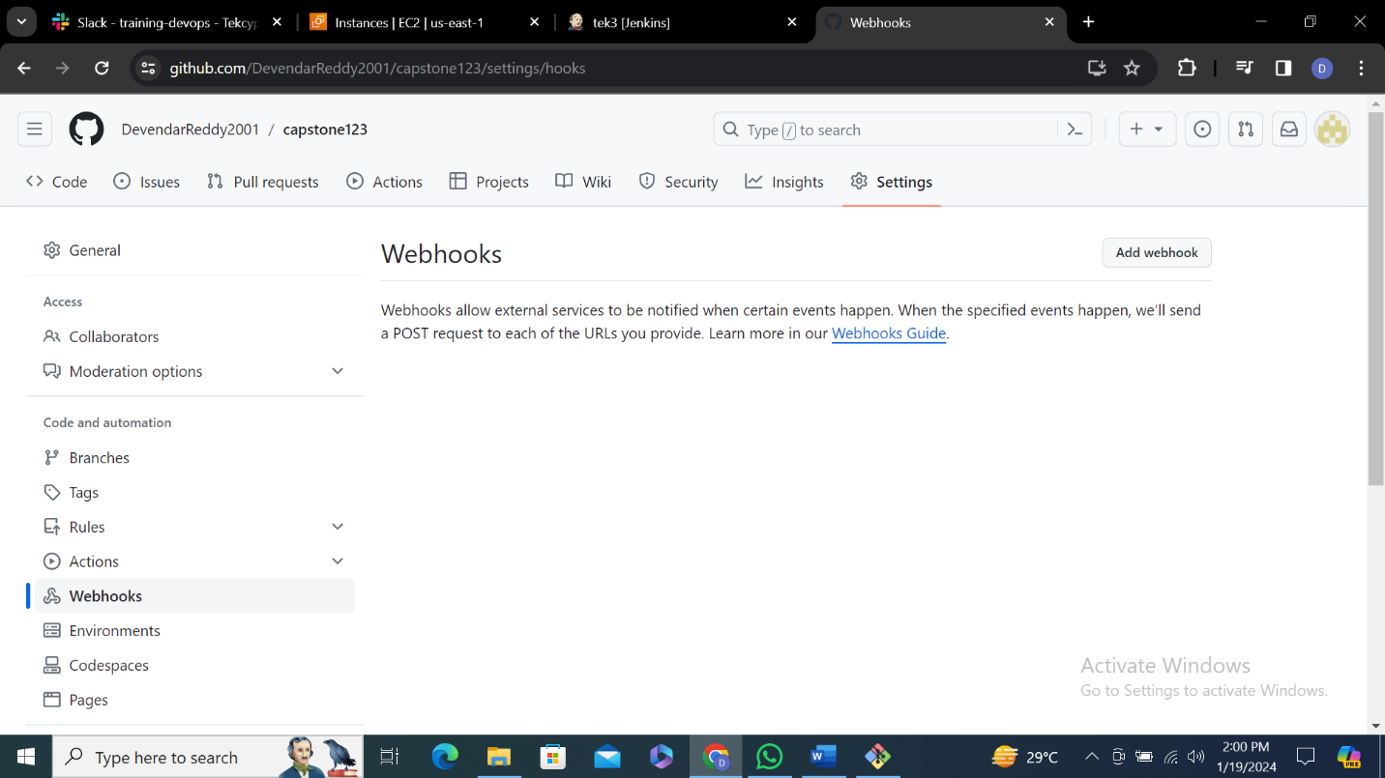

6.In payload url paste Jenkins url

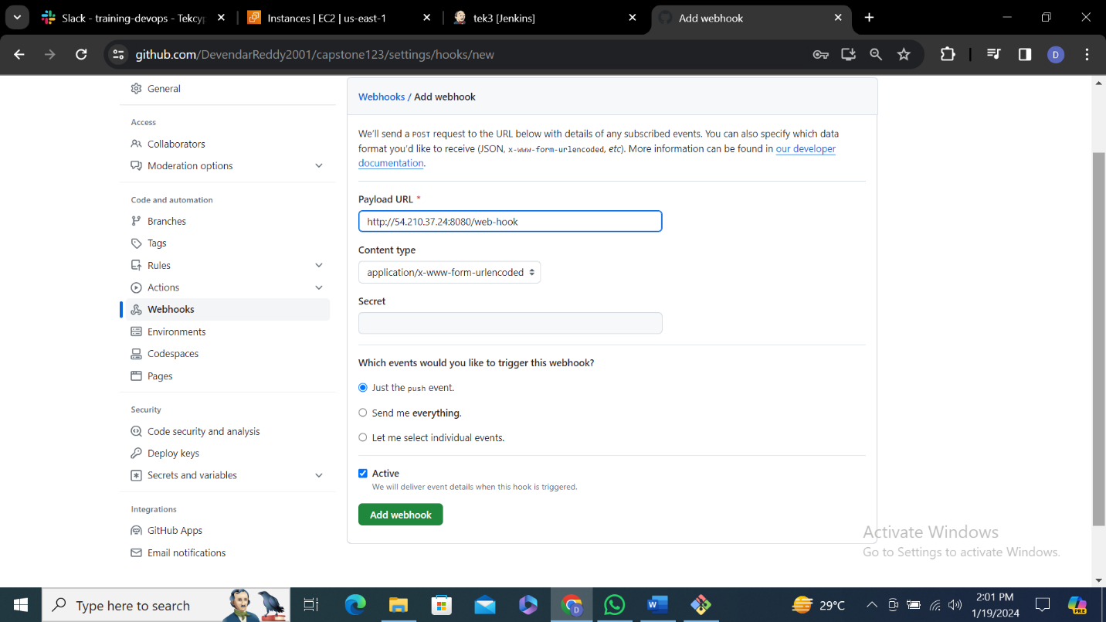

7.Open bash and create file and push file into remote repository

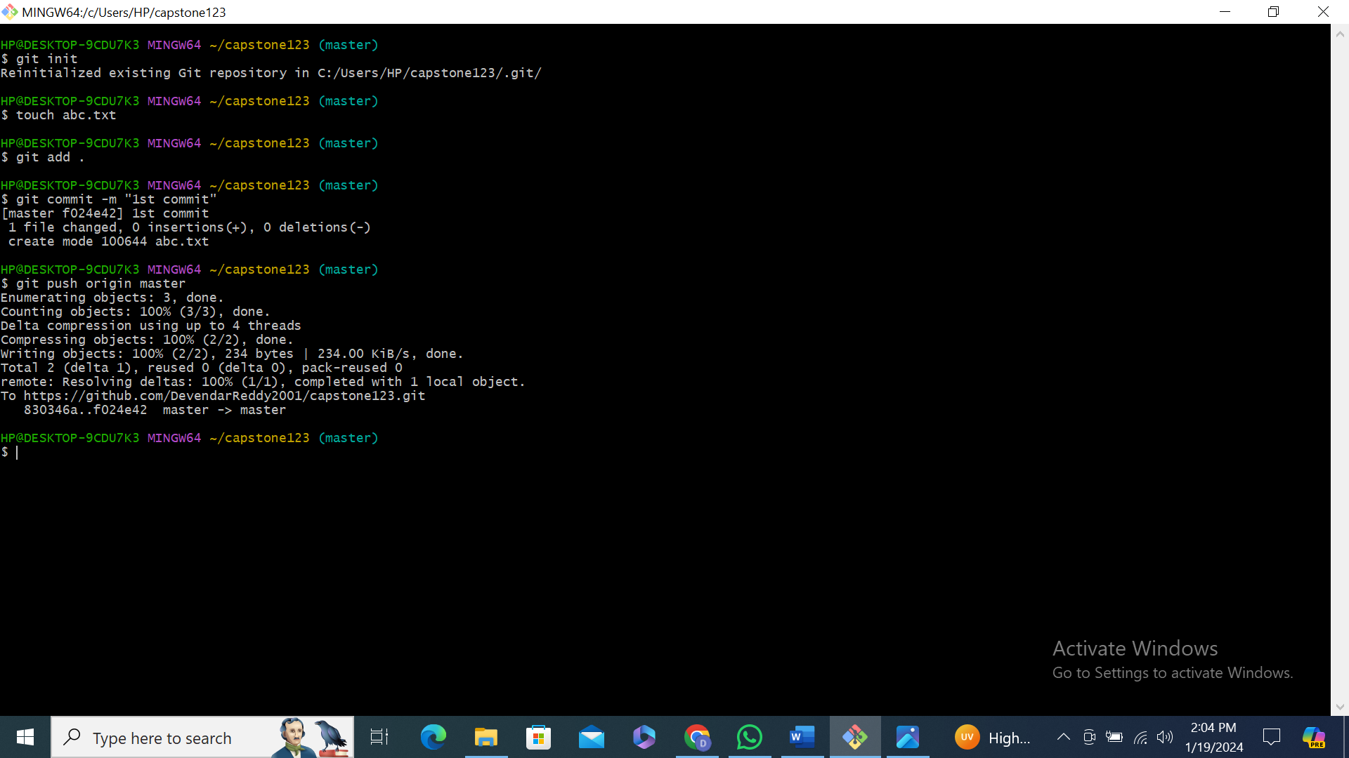

8.

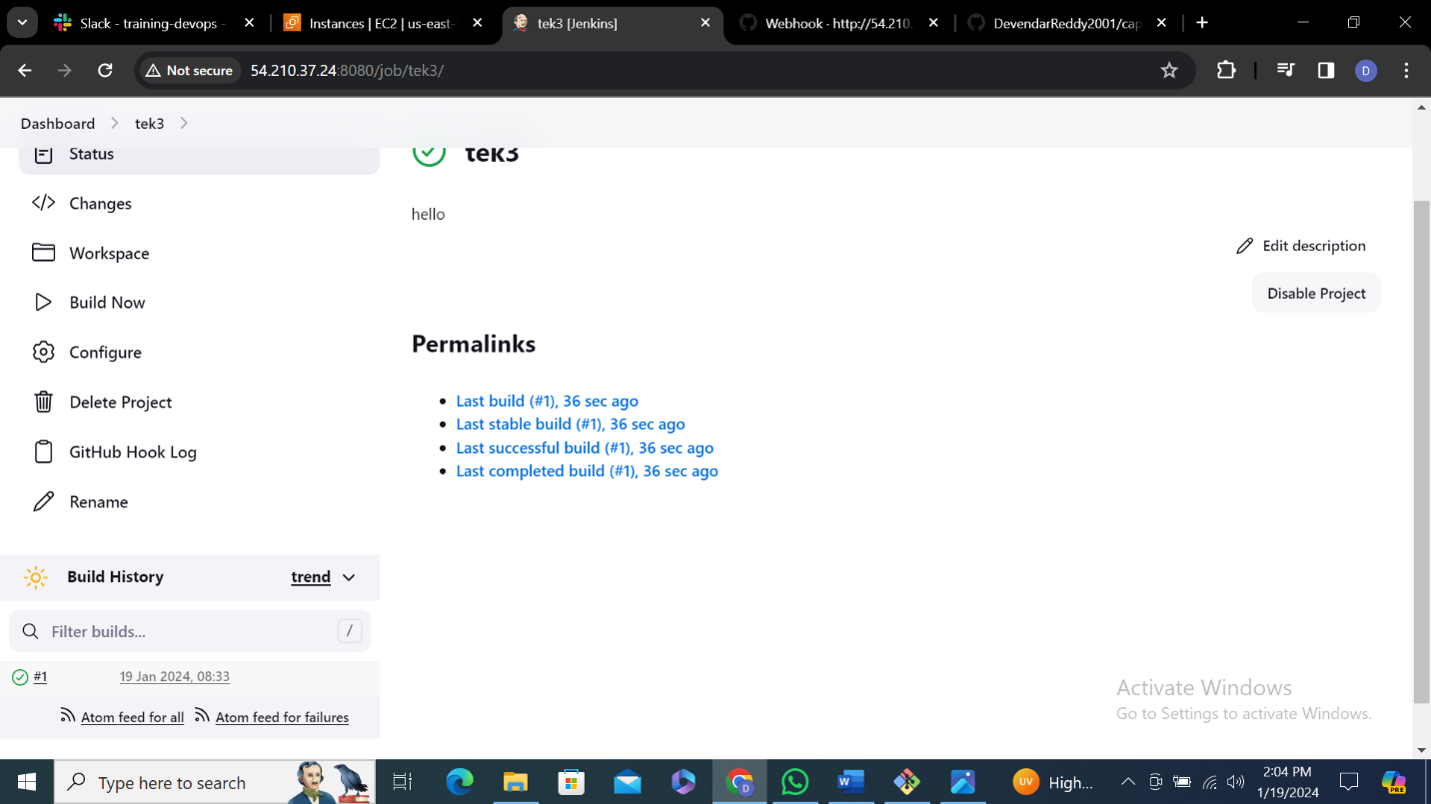

9.

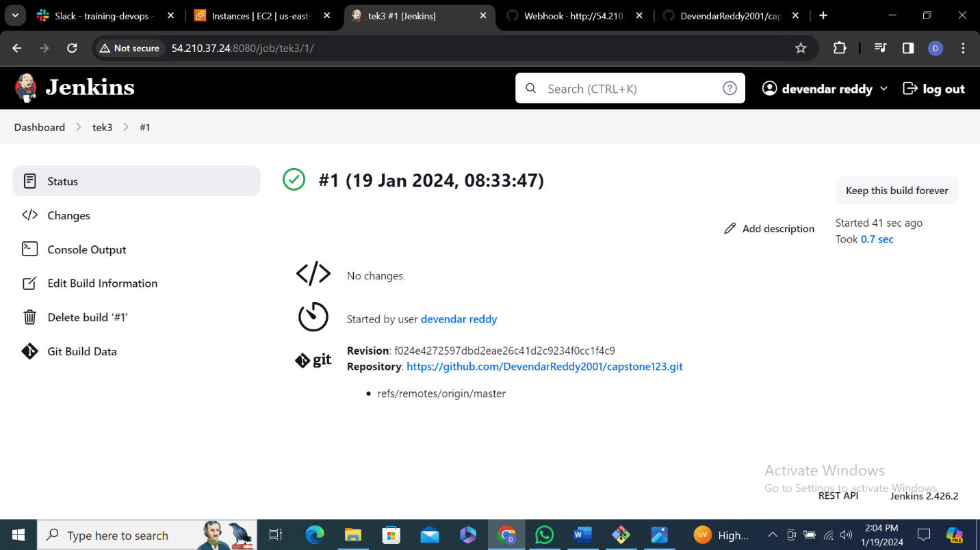

10.You will see the push file and commit id

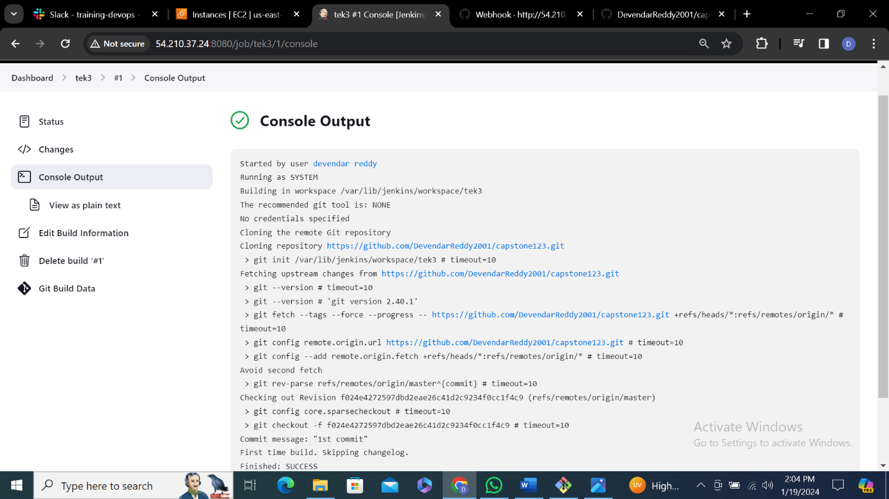

11.

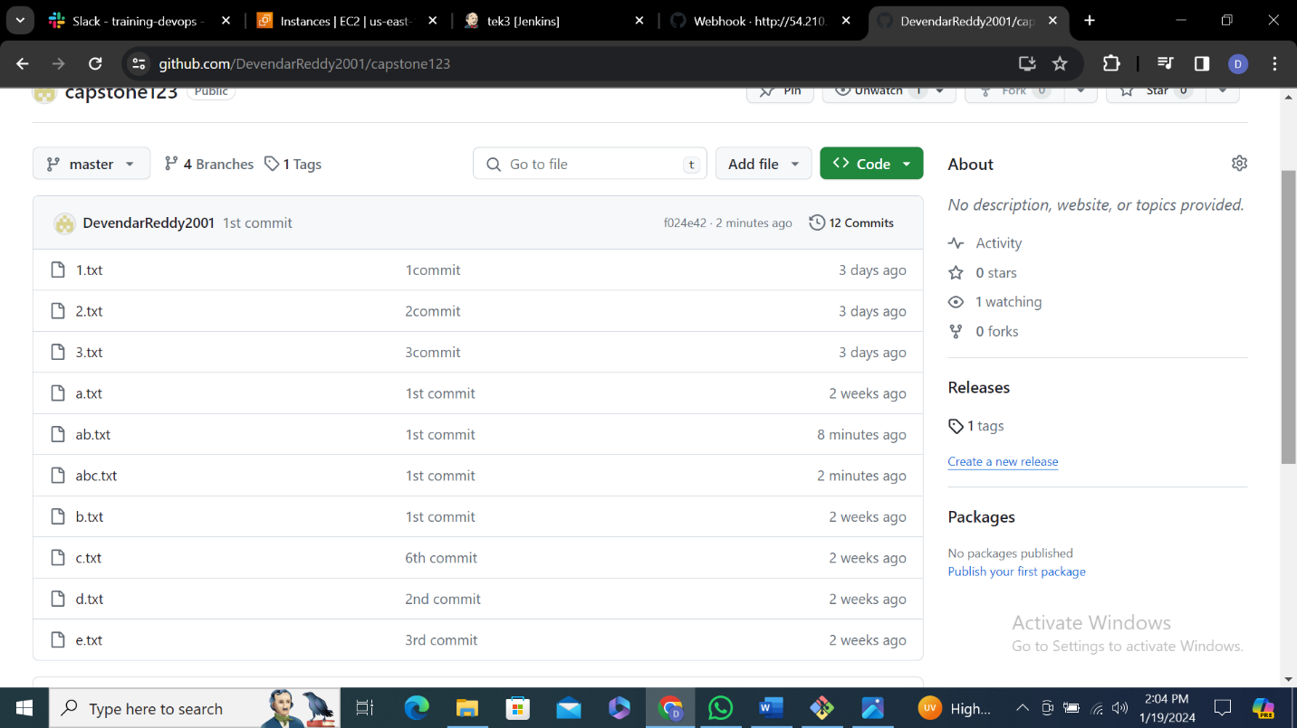

**Poll SCM**

**1.**Give description and paste git hub url

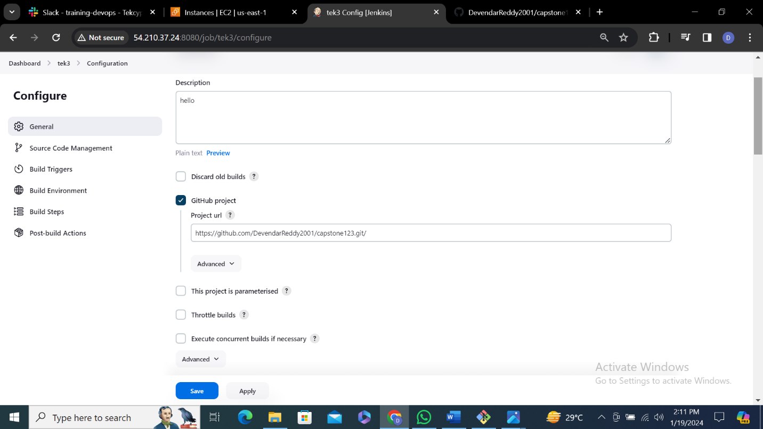

**2.**

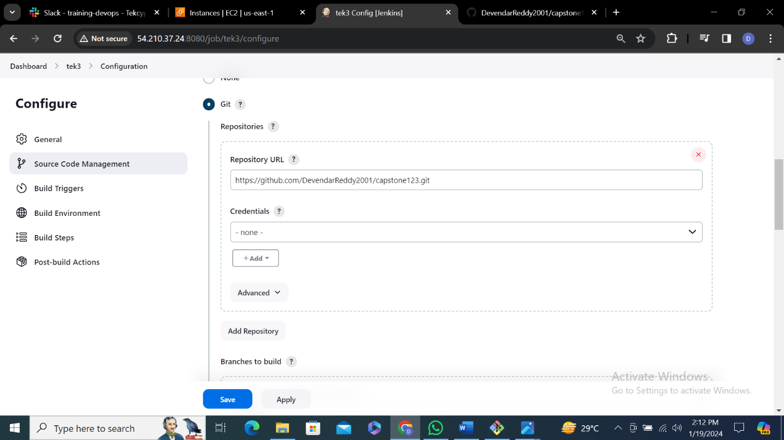

**3.** Select poll scm and enter * * * * * so that it will run

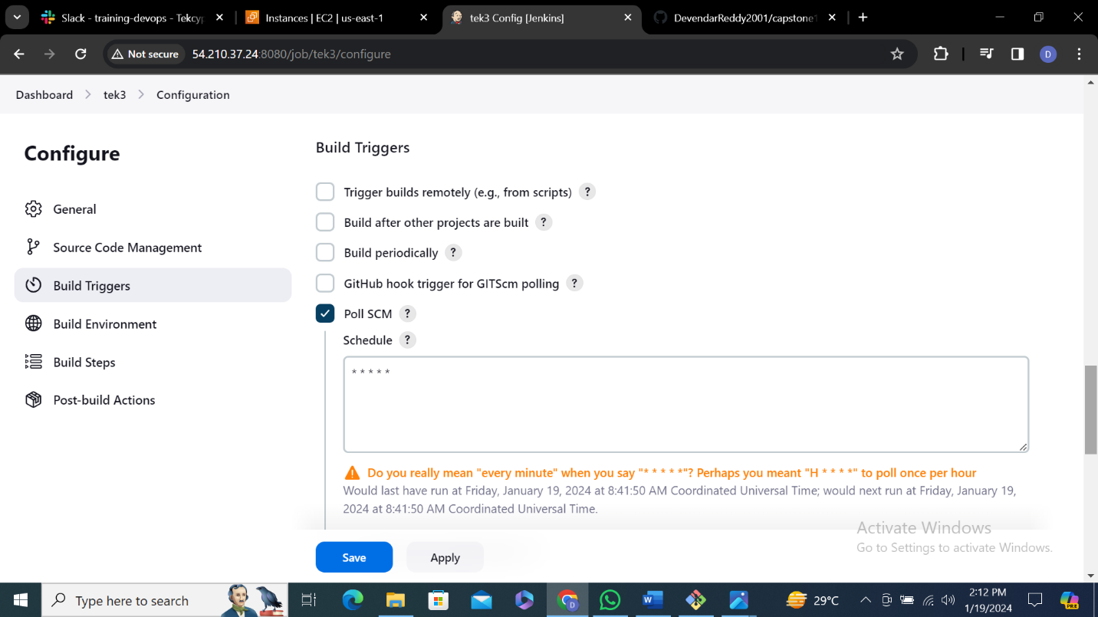

**4.**Click on save

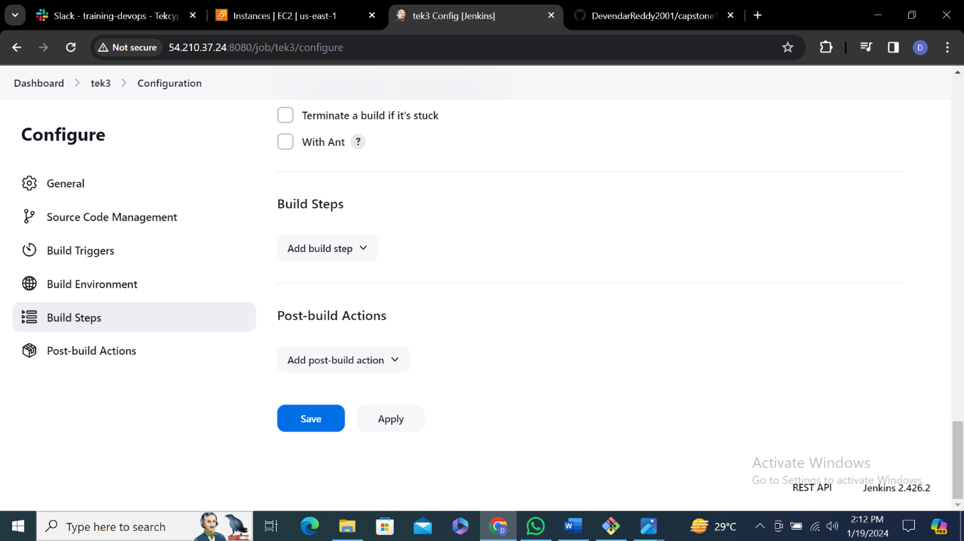

**5.**Make sure it runs successfully

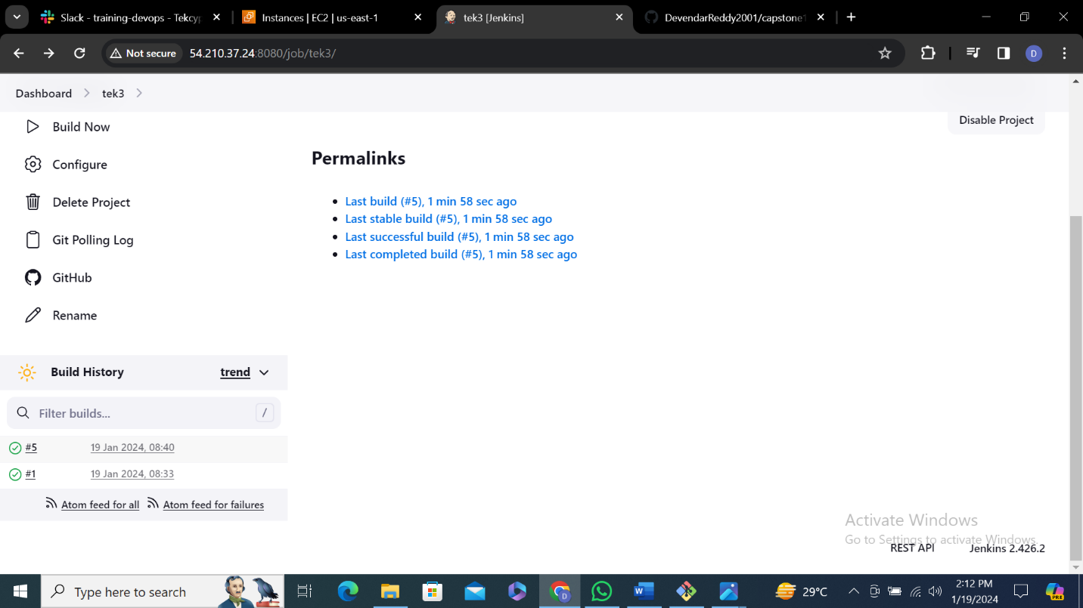

**6.**

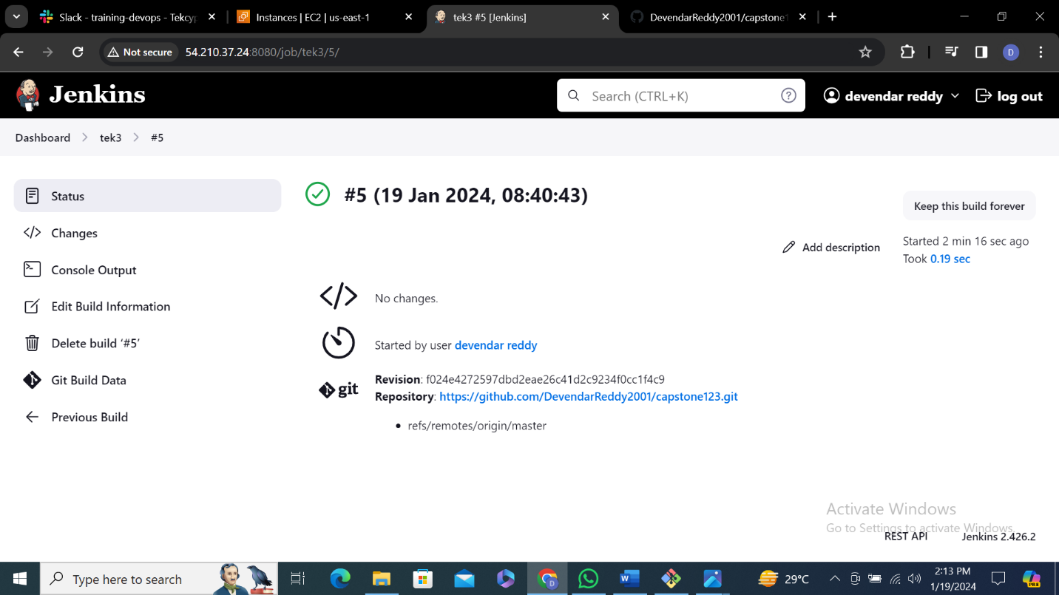

**7.**

